Road Traffic Simulation of Ayala Boulevard - San Marcelino Intersection

Genevive S. Macrayo  
*Technological University of the Philippines - Manila*  
*College of Science, Computer Science Department*Bacoor City, Philippines  
genevive.macrayo@tup.edu.ph

Aaron Christian D. Reyes  
*Technological University of the Philippines - Manila*  
*College of Science, Computer Science Department*Bulacan, Philippines  
aaronchristian.reyes@tup.edu.phJerecho P. Dalangin  
*Technological University of the Philippines - Manila*  
*College of Science, Computer Science Department*Manila, Philippines  
jerecho.dalangin@tup.edu.ph

Christian Vitto  
*Technological University of the Philippines - Manila*  
*College of Science, Computer Science Department*Oriental Mindoro, Philippines  
christian.vitto@tup.edu.ph

***Abstract*—Road traffic management has evolved into a global concern. Several traffic simulators have been developed to aid in the resolution of traffic congestion issues. Comparative simulator studies in this field of activity are concerned with comparing simulation results to real-world results; others are interested in the ability of certain platforms to simulate public transportation systems. Traffic simulation is a widely used method in traffic modeling research, planning, and development of traffic networks and systems.**

**Discrete Event Simulation (DES) is a well-known traditional approach to solving queuing system problems and running simulation models on different traffic scenarios for bottleneck analysis. Lower values for the cumulative average of all the parameters indicated that traffic congestion was reduced and that the traffic jam was avoided.**

***Keywords—road traffic simulation, discrete event simulation (****key words****)***

# Introduction

In our current era, driving is directly influenced by other entities, especially by what other road users around us do. May it be a vehicle driving faster, slower, or moving lanes - An entire traffic flow comes into light from the summation of the actions done by individual drivers.

Traffic modeling is done to accurately depict or recreate traffic as observed and measured on streets.In the auto industry and in research, it is common to create virtual traffic microsimulations. They create the traffic flow by generating the movements of vehicles, just as in reality. The result is a multitude of scenarios with different numbers of vehicles and realistic driving behaviors. Therefore, with traffic flow simulation, the need to “imagine” such scenarios is replaced by a generic methodology.

Road traffic is becoming a more pressing issue, particularly in urban areas. To better understand the problems of urban congestion, we need to simulate this traffic. In general, a simulation is defined as a time-dependent dynamic representation of some part of the real world. It is a widely used tool for testing or evaluating a plan of action prior to its implementation. Several studies have resulted in the development of traffic simulation software, and the comparison of these simulators has been the subject of numerous articles.

This study will show how the simulation in the Ayala Boulevard Intersection close to TUP - Manila Campus works with the data given by the local authorities and implementing the Discrete Event Simulation.

# Related Works

Discrete-event simulation (DES) is a popular method for simulating the behavior of real-world systems using computer modeling and appropriate software. [1]Simulation modeling is widely used in operational research. [2,3,4,5]DES has applications in both the manufacturing and service sectors, including production lines, port management, pedestrian studies, and healthcare. Total production, average waiting time in queue, average time in system, average number of entities in queue, and resource utilization are among the output performance measures of interest to decision makers that can be collected with DES.

[6]The bottleneck networks of vehicular traffic flow necessitated a clear understanding and insight into the factors that determine the time and location of traffic breakdown. Congestion spreads throughout the network as the number of vehicles on the road continues to increase. There have been numerous research studies to address the issues. Simulation and modeling of related issues appear to be important to operational research, specifically the traffic flow dynamic for design, analysis, and management. As a result, this work concentrated on developing a simulation model for vehicular traffic flow in order to reduce traffic congestion in a smooth and low-density traffic flow system.

# Methods

1. *Data Collection*

As for the data collection process, the needed information for the discrete event road traffic simulation of San Marcelino was requested electronically through the Freedom of Information - MMDA site. To simulate the traffic flow of the intersection of Ayala Boulevard close to the TUP - Manila campus, the needed data of Annual Average Daily Traffic Count of the year 2018 specific to the intersections along Ayala Boulevard was utilized. Due to data provision limitations, the proponents were only able to get the peak hours and count from 6AM - 8PM.

The simulation will follow the flowchart as shown in the Figure 1 below, that as the process starts we will input the data on where the origin is going to destination points, calibrate the parameters, speed limit and safety space, place stoplights and pedestrians. And as the generated vehicles start in the origin, it will go to what is the influential entity affecting the vehicle and if yes it is a vehicle following model and if not it is a free-acceleration model that is going to update the speed and position. Later on, if the vehicle arrives at the destination point, it will be removed from the road segment and if it is not, the simulation will output the vehicle position in real time, traffic data, volume, density, speed, graphical display, road segment and vehicle movements. Last is if we want to terminate the simulation or if not, we will run it back again with iteration equals iteration +1, number of vehicles +1 and real time + time step.

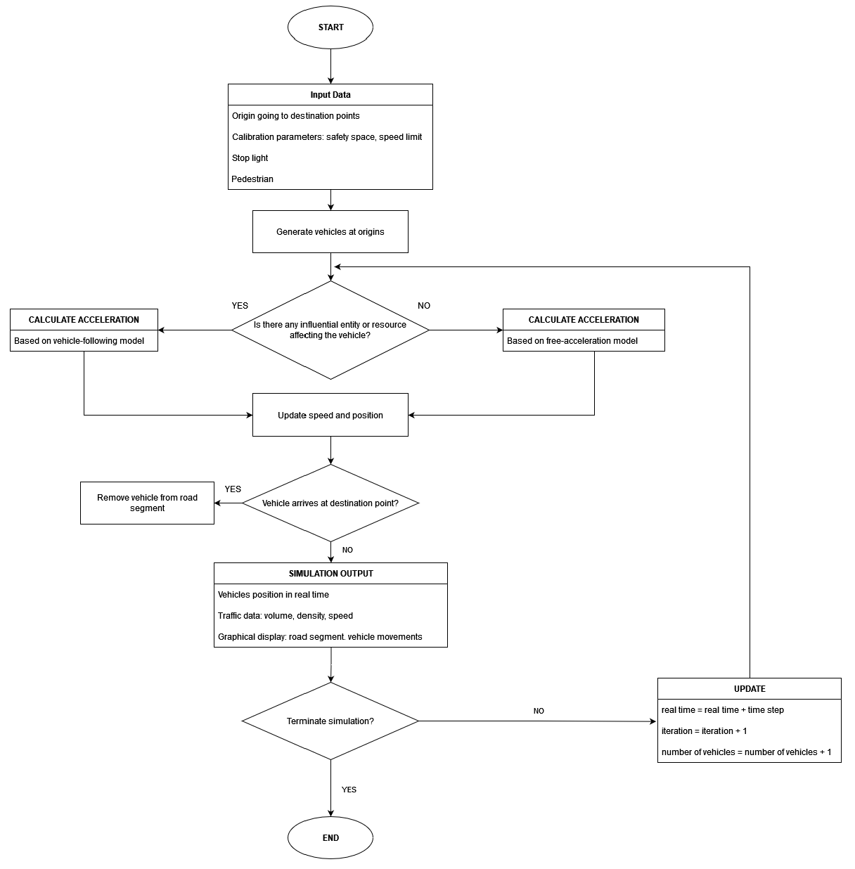

**Figure 1. Flowchart of the Traffic Flow Simulation**

*Discrete Event Simulation Model Development*

AnyLogic was utilized as the appropriate software to run the simulation as it provides a library that allows for traffic flow whilst delivering the most efficient road traffic design with clear visualizations. With these, there is the freedom to experiment and optimize accurate models, all important in road traffic analysis.

As for how the simulation looks in AnyLogic, it will be shown in Figure 2 which consists of how the pathway appears in the real-world, traffic lights, and the vehicles.

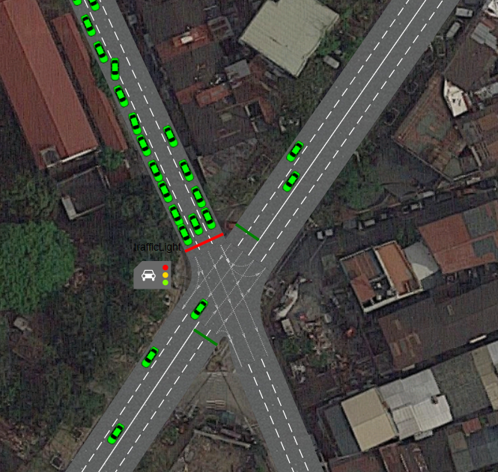

**Figure 2. AnyLogic Simulation with Road, Traffic Lights and Vehicles**

1. *Dataset Use*

In the simulation, we obtained the data from the FOI MMDA site that contains the number of cars, motorcycles, trucks and other vehicles during May of the year 2018 with its average volume count. The collected data was utilized to mimic real-world traffic scenarios for the establishment of actions and validation of the created model. All the data that has relation was then used in AnyLogic as shown in Figure 3 and further discussed in Figure 4.

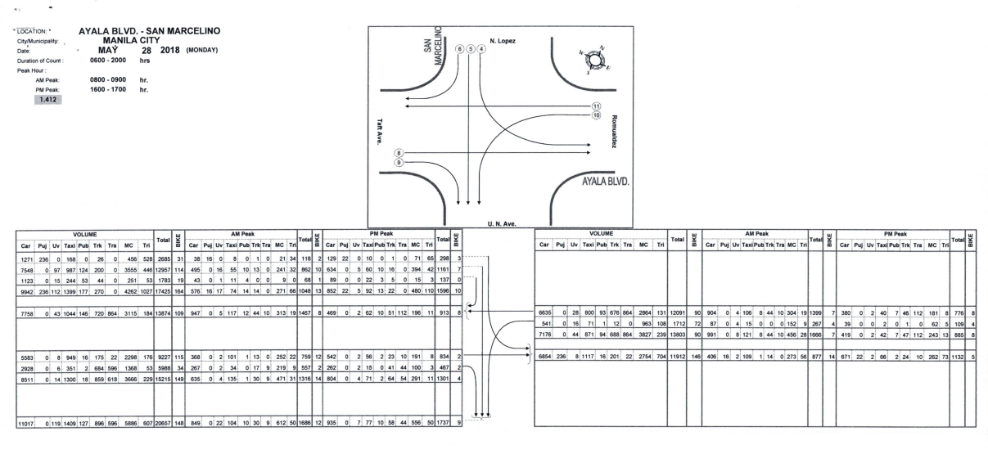

**Figure 3. Pathway of the Road and Number of Vehicles in a Day**

After the data was collected, we calculated the mean of the vehicles in each road and then we ratio the time of simulation to real-time. Due to AnyLogic’s in-app time constraints limited to an hour, a ratio had to be calculated to accurately simulate a 14-hour single day traffic congestion along the intersection. This is seen in Figure 4.

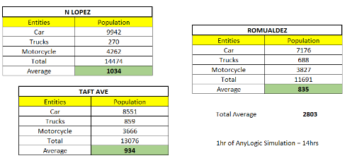

**Figure 4. Mean of the Dataset containing the number of cars, trucks, and motorcycles**

1. *Model Validation*

The validity of the model was statistically tested using T-Test and its P-value, with the simulation forecasting the total volume count of vehicles from the traffic flow along the intersection of Ayala Boulevard. The real dataset was requested from FOI MMDA from May 2018. Other parameters were based on the computed mean.

*Traffic Flow Discrete Event Simulation Model*

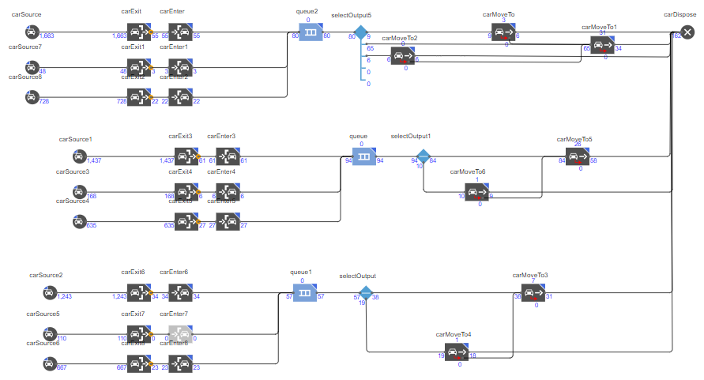

**Figure 5. Traffic Flow Simulation Model**

The figure above shows the simulation model of the traffic flow in Ayala Boulevard - San Marcelino Street Intersection. The first elements of the model which is the car source has the function of producing cars that will go to the next elements which are the car exit and enter then they will line up to queuing. And after the process of queuing, the vehicles will move to their respective places and will be put to the element car disposal that represents the datas collected in the dataset.

# Results and Discussion

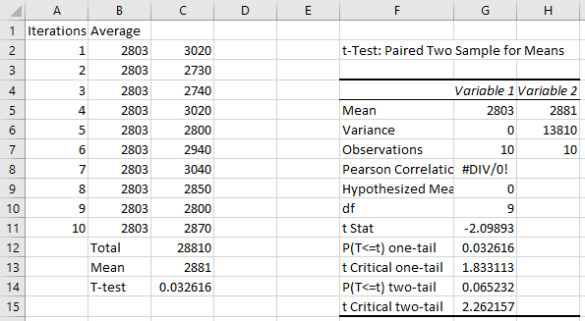

Based on the results of the simulation, the intersection of the Ayala Blvd., San Marcelino St. has an average of 2881 vehicles crossing the road. The original dataset has the average of 2803 so it still validates the number of the vehicles in the intersection based on the conducted paired t-test analysis. As seen in the results, there is no significant difference in data of the simulation and the calculated data of the given dataset by FOI MMDA which signifies that the data extracted from the simulation is almost the same as the given dataset. The simulation was run ten times to get the average or mean. Afterwards, its validity was tested using paired t-tests.

The following graph shows the mean runtime of the entities - cars, trucks, and motorcycles in the model. The mean time was calculated from the time an entity entered the model minus the time the entity leaves the model. AnyLogic computes the mean time of the entities in the model and displays it in the graph in real time. It also shows the population of the entities that are currently running inside the model.

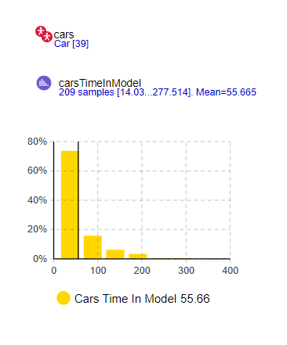

**Figure 6. Mean Runtime of Cars**

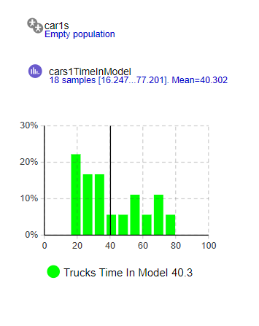

**Figure 7. Mean Runtime of Trucks**

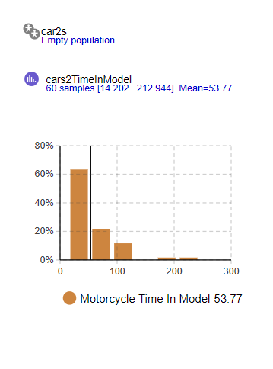

**Figure 8. Mean Runtime of Trucks**

# Conclusion

The problem raised in the entirety of this work is the existence of road traffic that is consistently becoming a more pressing issue, particularly in urban and developing areas. To better understand the problems of urban congestion, we need to simulate traffic as these changes have economic consequences that are unforgiving when left unsolved. Available Road Traffic Libraries allow for the modeling and simulation of vehicle traffic that serves as a platform in road traffic planning and engineering.

A model has been created for simulating the road traffic of the intersection of San Marcelino along Ayala Boulevard. The validity range of the model spans that of the entering and exit of vehicles whilst being affected by variables such as traffic and stop lights. The model was employed to mimic that of a regular day of traffic along the intersection.

Modeling by means of Discrete Event Simulation (DES) has been seen to have its own share of advantages and disadvantages. The traffic flow simulation has room for improvement by testing out other available methods, understanding the problem in detail, and using other parameters along with ratios that can further assess existing traffic congestion so that road flow and renovation can be done in the future.

##### Acknowledgment

First of all, to the Almighty God, for the knowledge and wisdom given to us that guided us throughout this project. For protecting us and keeping us safe and healthy to be able to finish this project. You alone have and will always be deserving of Glory!

To our parents, for their never-ending love and support. Without them we won’t have the strength to pursue and complete this project.

To our friends, who shared the same sleepless nights and struggles trying to come up with different ideas to build and train a model throughout the semester.

Lastly, to our professor, Mr. Jan Eilbert Lee, for the approval of the project, insights, and guidance in creating this project that led to a complete model and system. Thank you as you made this project possible!

##### References

1. Kelton, D. W., R. P. Sadowski, and N. B. Zupick. 2015. Simulation with Arena. 6th ed. New York: McGraw-Hill.
2. Desa, W L H Mat, S Kamaruddin, M K M Nawawi, and J Zulkepli. 2015. “Evaluation on Absenteeism Effect in Production Line at Aircraft Composite Manufacturer.” Jurnal Teknologi 77(5).
3. Khalid, R, M. A Baten, M K M Nawawi, and N Ishak. 2016. “Analyzing and Optimizing Pedestrian Flow through a Topological Network Based on M / G / C / C and Network Flow Approaches.” Journal of Advanced Transportation 50(1): 96– 119. http://doi.wiley.com/10.1002/atr.1330 (March 23, 2016).
4. Nawawi, M K M, F C Jamil, and F M Hamzah. 2015. “Evaluating Performance of Container Terminal Operation Using Simulation.” AIP Conference Proceedings 1660(1). http://scitation.aip.org/content/aip/proceeding/aipcp/10.1063/1.4 926640
5. Sharif, N A M, A Aziz, N Ahmad, and M K M Nawawi. 2016. “Modelling an Outpatient Unit in a Clinical Health Centre Using Discrete Event Simulation.” AIP Conference Proceedings 1782(1): 40018. http://aip.scitation.org/doi/abs/10.1063/1.4966085.
6. Bakar, N. A. A., Adi, A. F. N., Majid, M. A., Adam, K., Younis, Y. M., & Fakhreldin, M. (2018). The Simulation on Vehicular Traffic Congestion Using Discrete Event Simulation (DES): A Case Study. 2018 International Conference on Innovation and Intelligence for Informatics, Computing, and Technologies (3ICT). https://doi.org/10.1109/3ict.2018.8855781